LOCAL
NEW BUSINESS, NEW OPPORTUNITIES
The team at Portland Port recently managed to negotiate an opportunity to get Sir Tristram berthed alongside for a major refit project, which in turn opened up prospects for local businesses to benefit. Originally the Sunderland based UK Docks were planning to undertake the refit whilst the vessel was at anchor, however Portland Port was able to consult with them to provide a suitable berth, instantly opening up opportunities for local suppliers to be involved.
The project provided a boost not only to local suppliers and contractors, but also more specifically the hospitality sector. The Studio B&B in Weymouth and the Portland based Royal Breakwater Hotel witnessed an increase in bookings, as they were able to accommodate the 30 plus crew brought into the area by UK Docks to complete the project.
Harry Wilson, managing director of UK Docks who won the contract was available to comment; “With the help of Portland Port and local contractors we were able to meet the contractual obligations and deliver the contract on time”. The project was such a success that it saw Sir Tristram moved out to anchor on Thursday the 25th April, 3 days earlier than anticipated.
Also arriving independently of UK Docks is the specialist marine drilling contractor, Fugro Seacore, who are using Portland Port to carry out essential maintenance on the “Excalibur” jack-up barge. These operations within the port will also have a positive effect on the local economy, with the extra numbers they have brought to the area to carry out the maintenance. The port continues to support and invest in the local economy by bringing in new business every year; it outsources operations locally where it can so that local businesses can benefit.
The port is more than capable of handling vessels the size of Sir Tristram and has plenty to offer in terms of repair and maintenance. The inner harbour, sheltered by the breakwater, is an ideal location for ships to anchor, carry out maintenance tasks or to shelter from hostile weather conditions. It is these qualities that have allowed new partnerships to form with UK Docks and Fugro Seacore; relationships that Portland Port is looking forward to developing as it seeks to continue to facilitate contractual requirements in vessel repairs and refits.
NOTES TO EDITOR
Sir Tristram served during the Falklands war, in which she was badly damaged in 1982. She was brought back to the UK in 1983 and was extensively rebuilt, repaired and lengthened. Since then she remained in service until December 2005, when she retired to Portland Port to take on a static training role for the Royal Navy. The latest chapter in the history of Sir Tristram is another milestone in the lasting relationship between Portland Port and the MoD and its ongoing contract to support them with their activities, repairs and manoeuvres wherever possible.
Previously a naval dockyard for over 150 years, Portland Harbour is now a thriving and successful commercial facility. It still maintains a close relationship with the past through its ongoing contract to support the RFA, as well as being home to the activities of Global Marine and Portland Bunkers International. It has over 4,000 acres of water at depths of up to 15m (C.D.); and provides vessel services from long term lay-ups to brief maintenance calls, luxury cruise liner docking facilities to industrial cargo shipments.
General Portland Harbour Authority information can be viewed at http://www.portland-port.co.uk/

TRADE
NEW BUSINESS, NEW OPPORTUNITIES
The team at Portland Port recently managed to negotiate an opportunity to get Sir Tristram berthed alongside for a major refit project, which in turn opened up prospects for more local businesses to benefit. Originally the Sunderland based UK Docks were planning to undertake the refit whilst the vessel was at anchor, however Portland Port was able to consult with them to provide a suitable berth, instantly opening up opportunities for local suppliers to be involved.
Harry Wilson, managing director of UK Docks, who won the contract for the project was available to comment; “With the help of Portland Port and local contractors we were able to meet the contractual obligations and deliver the project on time”. The project was such a success that it saw Sir Tristram moved out to anchor on Thursday the 25th April, 3 days earlier than anticipated.
Also arriving independently of UK Docks is the specialist marine drilling contractor, Fugro Seacore, who are using Portland Port to carry out essential maintenance on the “Excalibur” jack-up barge. These operations within the port will also have a positive effect on the local economy with the extra numbers they have brought to the town. The port continues to support and invest in the local economy by bringing in new business every year; it outsources operations locally where it can so that local companies can equally benefit.
Portland Port is capable of handling a wide variety of vessels, from barges to much bigger vessels of up to 300m and has plenty to offer in terms of repair and maintenance. The inner harbour, sheltered by the breakwater, is an ideal location for offshore vessels like the “Excalibur”, to carry out maintenance tasks or to shelter from hostile weather conditions. It is such qualities that have allowed new partnerships with UK Docks and Fugro Seacore to form and the port looks forward to working with both companies again for future projects.

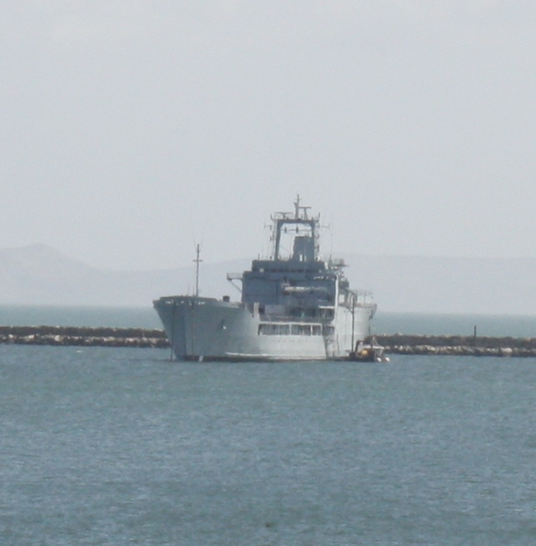
Sir Tristram after refit.

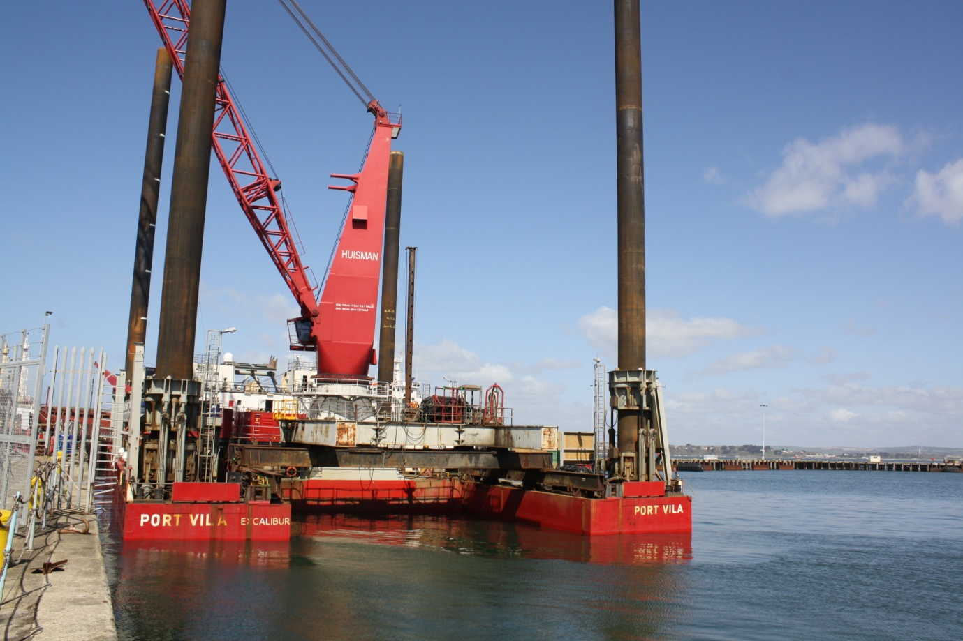
Fugro Seacore jack-up barge “Excalibur“
__________________________________________________________________
NOTES TO EDITOR
Sir Tristram served during the Falklands war, in which she was badly damaged in 1982. She was brought back to the UK in 1983 and was extensively rebuilt, repaired and lengthened. Since then she remained in service until December 2005, when she retired to Portland Port to take on a static training role for the Royal Navy. The latest chapter in the history of Sir Tristram is another milestone in the lasting relationship between Portland Port and the MoD and its ongoing contract to support them with their activities, repairs and manoeuvres wherever possible.
Previously a naval dockyard for over 150 years, Portland Harbour is now a thriving and successful commercial facility. It still maintains a close relationship with the past through its ongoing contract to support the RFA, as well as being home to the activities of Global Marine and Portland Bunkers International. It has over 4,000 acres of water at depths of up to 15m (C.D.); and provides vessel services from long term lay-ups to brief maintenance calls, luxury cruise liner docking facilities to industrial cargo shipments.
General Portland Harbour Authority information can be viewed at http://www.portland-port.co.uk/
For further information contact: j.brooke@portland-port.co.uk

