START

THE END OF THE CRUISE SEASON FOR PORTLAND PORT WITH A RECORD BREAKING SHIP

Portland Port's cruise season has now come to an end, but it has been a spectacular finale with the arrival of the enormous Norwegian Getaway that docked at the port this morning. It is not only Norwegian Getaway's inaugural call to Portland Port, but she is also the largest ship to visit this year.
Norwegian Cruise Line has a 50-year history in the cruise business and was responsible for introducing Freestyle Cruising that revolutionised the industry by giving guests the freedom and flexibility to design their ideal cruise holiday. They currently operate 17 purpose built freestyle cruising ships which include some of the newest and most contemporary ships at sea.
The arrival of the Norwegian Getaway is exciting for the port’s cruise business; she is the longest and heaviest vessel to dock at Portland Port this season. This cruise liner can accommodate up to 5000 people, so has brought with her the greatest number of passengers on one ship that the port has had to deal with so far. Portland Port have provided 12 shuttle buses to enable everyone on board to enjoy their time in Dorset and the surrounding area, and ensure they are all given a memorable experience.
Ian McQuade General Manager -Commercial said “The inaugural call of the Norwegian Getaway is very exciting; we welcomed her sister ship the Norwegian Breakaway in 2018 and hoped then that she would be the first of many similar sized cruise ships to visit us. Ending the season with such a momentous ship really has felt as if we have gone out with a bang, and everyone at Portland Port is already looking forward to 2020’
Over the last 10 years the number of cruise ships visiting the Port has grown substantially, and it’s been a record breaking season with the greatest number of cruise calls and passengers to date. Overall in 2019 the port has handled over 40 cruise ships bringing around 60,000 passengers to the area, this is great for the local economy and a trend that Portland Port is keen to continue for next year.
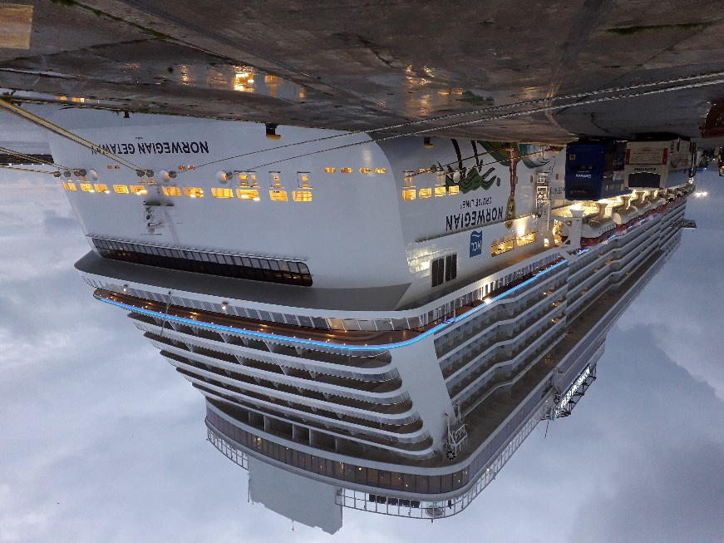
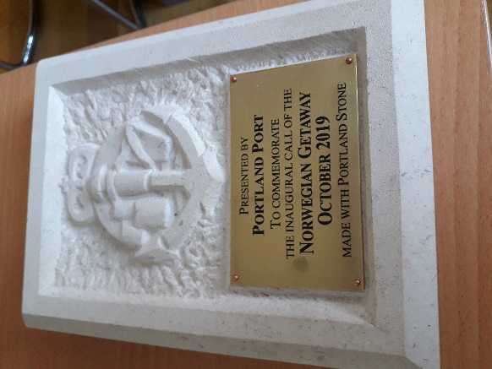

NOTES TO EDITORS
P1: Portland Stone Plaque given to the ship
P2: The Norwegian Getaway
For more information or images please contact Jayne Bateman at Portland Port on 01305 825368
or email j.bateman@portland-port.co.uk.

Previously a naval dockyard for over 150 years, Portland Harbour is now a thriving and successful commercial facility. It still maintains a close relationship with the past through its ongoing contract to support the RFA, as well as being home to the activities of Global Marine and Portland Bunkers UK. It has almost 2,500 hectares of water at depths of up to 15m (C.D.); and provides vessel services from long term lay-ups to brief maintenance calls, luxury cruise liner docking facilities to industrial cargo shipments.
The tariff and general Portland Harbour Authority information can be viewed at
http://www.portland-port.co.uk/

M/F
Portland Port has over 2,000 metres of alongside berths and 11.6 metres (C.D.) depth of water at the deepest alongside berth.
Berthing for vessels up to 340 metres (subject to Harbour Master's approval).
11 designated anchorages are within the 1,015-hectare inner harbour.
Six designated anchorages are within the 1,436-hectare Outer Harbour.
A width of 210 metres and depth of over 12.6 metres (C.D.) at the entrance of the harbour mean that there are few vessel beam, lock, or air draft restriction.
END

